The Character Streams and Multithreaded Programming

Lab No. | Experiment / Program
1. | Write a Java program to read characters from the keyboard using Reader and display them on the console using Writer.
import java.io.*;

public class ReaderWriterDemo {
public static void main(String[] args) throws IOException {
Reader reader = new InputStreamReader(System.in);
Writer writer = new OutputStreamWriter(System.out);

System.out.println("Enter text. Press Ctrl+D (Linux/macOS) or Ctrl+Z (Windows) to stop:");

int ch;
while ((ch = reader.read()) != -1) {
writer.write(ch);
writer.flush();
}
}
}
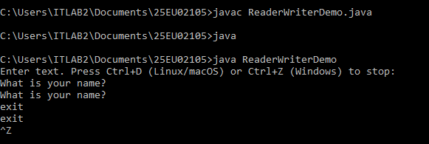
2 | Write a Java program to read the contents of a text file using FileReader and display them on the console.

import java.io.*;

public class ReaderFile {
public static void main(String[] args) {
try {
FileReader reader = new FileReader("input.txt");

int ch;
while ((ch = reader.read()) != -1) {
System.out.print((char) ch);
}

reader.close();
} catch (IOException e) {
System.out.println("Error: " + e.getMessage());
}
}
}
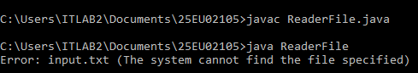
3 | Write a Java program to write text into a file using FileWriter.
import java.io.*;

public class WriterFile {
public static void main(String[] args) {
try {
FileWriter writer = new FileWriter("output.txt");

writer.write("This text is written using FileWriter.\n");
writer.write("Java character streams are useful for text files.");

writer.close();

System.out.println("Data written successfully.");
} catch (IOException e) {
System.out.println("Error: " + e.getMessage());
}
}
}
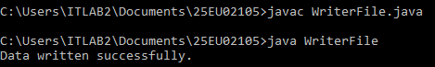

4 | Write a Java program to copy the contents of one text file into another using FileReader and FileWriter.
import java.io.*;

public class CopyingFile {
public static void main(String[] args) {
try {
FileReader reader = new FileReader("source.txt");
FileWriter writer = new FileWriter("destination.txt");

int ch;
while ((ch = reader.read()) != -1) {
writer.write(ch);
}

reader.close();
writer.close();

System.out.println("File copied successfully.");
} catch (IOException e) {
System.out.println("Error: " + e.getMessage());
}
}
}
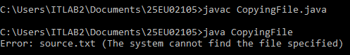

5 | Write a Java program to count the number of characters, words, and lines in a text file using character streams.
import java.io.*;

public class FileCount {
public static void main(String[] args) {
int characters = 0;
int words = 0;
int lines = 0;

try {
FileReader reader = new FileReader("input.txt");
BufferedReader bufferedReader = new BufferedReader(reader);

String line;

while ((line = bufferedReader.readLine()) != null) {
lines++;
characters += line.length();

String trimmedLine = line.trim();

if (!trimmedLine.isEmpty()) {
String[] wordList = trimmedLine.split("\\s+");
words += wordList.length;
}
}

bufferedReader.close();

System.out.println("Characters: " + characters);
System.out.println("Words: " + words);
System.out.println("Lines: " + lines);
} catch (IOException e) {
System.out.println("Error: " + e.getMessage());
}
}
}
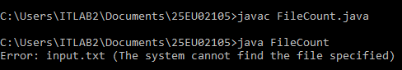

6 | Write a Java program to demonstrate the Main Thread and display its name, priority, and state.
public class MainThreadDemo {
public static void main(String[] args) {
Thread mainThread = Thread.currentThread();

System.out.println("Thread name: " + mainThread.getName());
System.out.println("Thread priority: " + mainThread.getPriority());
System.out.println("Thread state: " + mainThread.getState());

mainThread.setName("MyMainThread");
mainThread.setPriority(Thread.MAX_PRIORITY);

System.out.println("\nAfter modification:");
System.out.println("Thread name: " + mainThread.getName());
System.out.println("Thread priority: " + mainThread.getPriority());
System.out.println("Thread state: " + mainThread.getState());
}
}
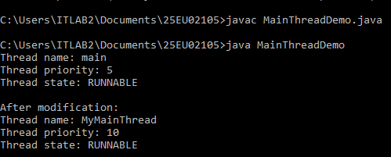

7 | Write a Java program to create a thread by extending the Thread class.
class MyThread extends Thread {
public void run() {
for (int i = 1; i <= 5; i++) {
System.out.println("Child thread: " + i);

try {
Thread.sleep(500);
} catch (InterruptedException e) {
System.out.println("Thread interrupted.");
}
}
}
}

public class ThreadClassDemo {
public static void main(String[] args) {
MyThread thread = new MyThread();
thread.start();

for (int i = 1; i <= 5; i++) {
System.out.println("Main thread: " + i);
}
}
}
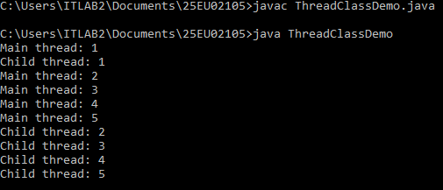

8 | Write a Java program to create a thread by implementing the Runnable interface.
class MyRunnable implements Runnable {
public void run() {
for (int i = 1; i <= 5; i++) {
System.out.println("Runnable thread: " + i);

try {
Thread.sleep(500);
} catch (InterruptedException e) {
System.out.println("Thread interrupted.");
}
}
}
}

public class RunnableDemo {
public static void main(String[] args) {
MyRunnable runnable = new MyRunnable();
Thread thread = new Thread(runnable);

thread.start();

for (int i = 1; i <= 5; i++) {
System.out.println("Main thread: " + i);
}
}
}
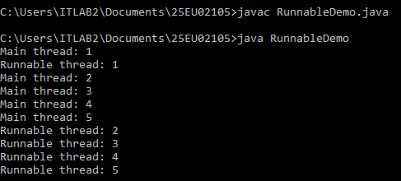

9 | Write a Java program to create multiple threads and demonstrate their concurrent execution.
class NumberThread extends Thread {
private String threadName;

NumberThread(String threadName) {
this.threadName = threadName;
}

public void run() {
for (int i = 1; i <= 5; i++) {
System.out.println(threadName + ": " + i);

try {
Thread.sleep(500);
} catch (InterruptedException e) {
System.out.println(threadName + " interrupted.");
}
}
}
}

public class MultipleThreads {
public static void main(String[] args) {
NumberThread thread1 = new NumberThread("Thread 1");
NumberThread thread2 = new NumberThread("Thread 2");
NumberThread thread3 = new NumberThread("Thread 3");

thread1.start();
thread2.start();
thread3.start();
}
}
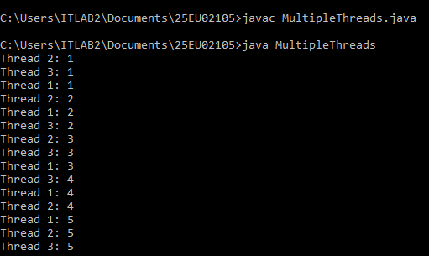

10 |  | Write a Java program to demonstrate the use of isAlive() method to check whether a thread is running.
class AliveThread extends Thread {
public void run() {
try {
Thread.sleep(2000);
} catch (InterruptedException e) {
System.out.println("Thread interrupted.");
}

System.out.println("Child thread has completed.");
}
}

public class IsAliveDemo {
public static void main(String[] args) {
AliveThread thread = new AliveThread();

System.out.println("Before start: " + thread.isAlive());

thread.start();

System.out.println("After start: " + thread.isAlive());

try {
Thread.sleep(3000);
} catch (InterruptedException e) {
System.out.println("Main thread interrupted.");
}

System.out.println("After completion: " + thread.isAlive());
}
}
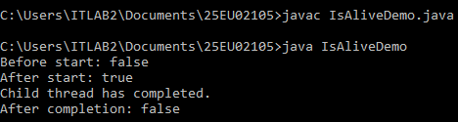

11 |  | Write a Java program to demonstrate the use of join() method to make one thread wait for another thread to complete.
class JoinThread extends Thread {
public void run() {
for (int i = 1; i <= 5; i++) {
System.out.println("Child thread: " + i);

try {
Thread.sleep(500);
} catch (InterruptedException e) {
System.out.println("Thread interrupted.");
}
}
}
}

public class JoinDemo {
public static void main(String[] args) {
JoinThread thread = new JoinThread();
thread.start();

try {
thread.join();
} catch (InterruptedException e) {
System.out.println("Main thread interrupted.");
}

System.out.println("Main thread continues after child thread completes.");
}
}
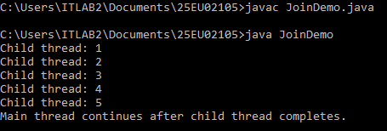

12 | Write a Java program to create multiple threads and use isAlive() and join() to control their execution order.
class WorkerThread extends Thread {
private String threadName;

WorkerThread(String threadName) {
this.threadName = threadName;
}

public void run() {
for (int i = 1; i <= 3; i++) {
System.out.println(threadName + ": " + i);

try {
Thread.sleep(500);
} catch (InterruptedException e) {
System.out.println(threadName + " interrupted.");
}
}
}
}

public class IsAliveJoinDemo {
public static void main(String[] args) {
WorkerThread thread1 = new WorkerThread("Thread 1");
WorkerThread thread2 = new WorkerThread("Thread 2");

thread1.start();
thread2.start();

System.out.println("Thread 1 alive: " + thread1.isAlive());
System.out.println("Thread 2 alive: " + thread2.isAlive());

try {
thread1.join();
System.out.println("Thread 1 completed.");

thread2.join();
System.out.println("Thread 2 completed.");
} catch (InterruptedException e) {
System.out.println("Main thread interrupted.");
}

System.out.println("Thread 1 alive: " + thread1.isAlive());
System.out.println("Thread 2 alive: " + thread2.isAlive());
System.out.println("All threads have completed.");
}
}


